Q1
SELECT
E.FirstName,
E.LastName,
E.EmployeeNumber,
firstname || ' ' || lastname, C.CUSTOMERNAME,
C.City,
C.Phone,
C.PostalCode
FROM RETAILCUSTOMERS C, RETAILEMPLOYEES E
WHERE
C.Country = 'Singapore'
AND C.SalesRepEmployeeNumber = E.EmployeeNumber;
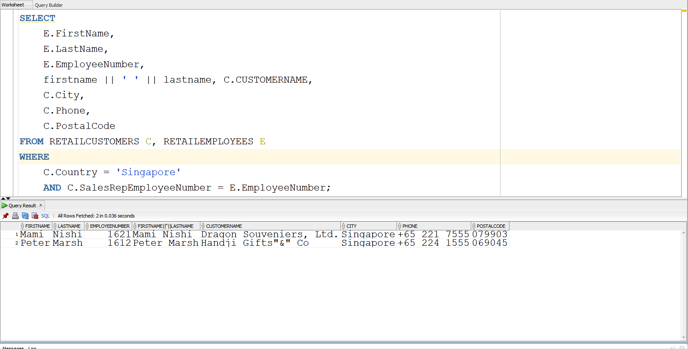
SELECT
E.FirstName,
E.LastName,
E.EmployeeNumber,
firstname || ' ' || lastname,
C.CUSTOMERNAME,
C.City,
C.Phone,
C.PostalCode
FROM RETAILCUSTOMERS C
JOIN RETAILEMPLOYEES E ON C.SalesRepEmployeeNumber = E.EmployeeNumber
WHERE C.COUNTRY = 'Singapore';
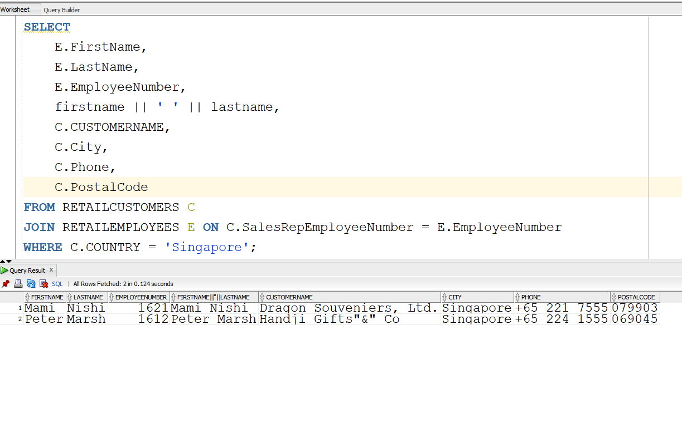

Q2
SELECT
P.CustomerNumber, C.CustomerName, C.COUNTRY,
TO_CHAR(P.PaymentDate, 'Mon DD, YYYY'),
P.Amount
FROM
RETAILPAYMENTS P
JOIN
RETAILCUSTOMERS C ON P.CustomerNumber = C.CustomerNumber
WHERE
C.Country = 'USA'
ORDER BY
P.CustomerNumber;
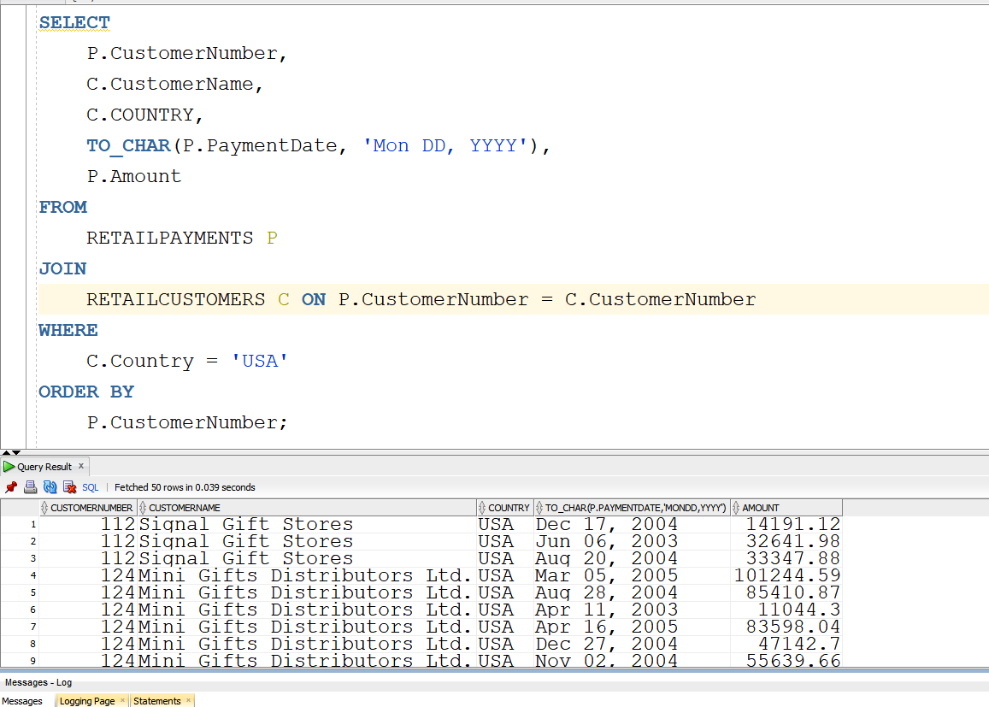
Q3
SELECT C.CustomerNumber, C.CustomerName, P.Amount
FROM RETAILCUSTOMERS C
JOIN RETAILPAYMENTS P ON C.CustomerNumber = P.CustomerNumber
WHERE C.Country = 'Canada'
ORDER BY C.CustomerNumber;
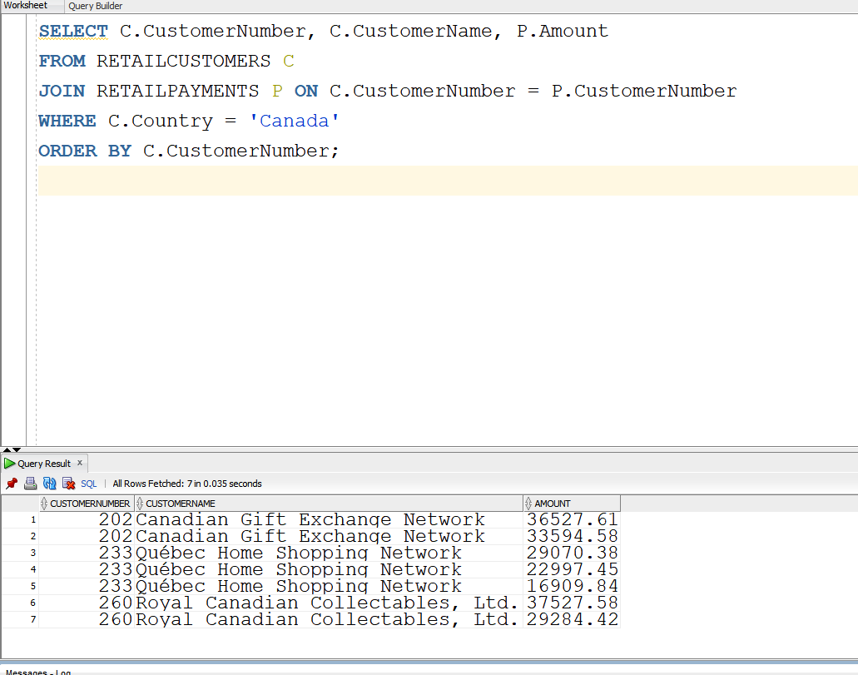

Q4
SELECT
O.ORDERNUMBER,
OD.QUANTITYORDERED,
OD.PRICEEACH,
C.CUSTOMERNAME
FROM
RETAILORDERS O
JOIN ORDERDETAILS OD ON O.ORDERNUMBER = OD.ORDERNUMBER
JOIN RETAILCUSTOMERS C ON O.CUSTOMERNUMBER = C.CUSTOMERNUMBER
WHERE
O.SHIPPEDDATE IS NOT NULL
AND C.COUNTRY = 'Denmark'
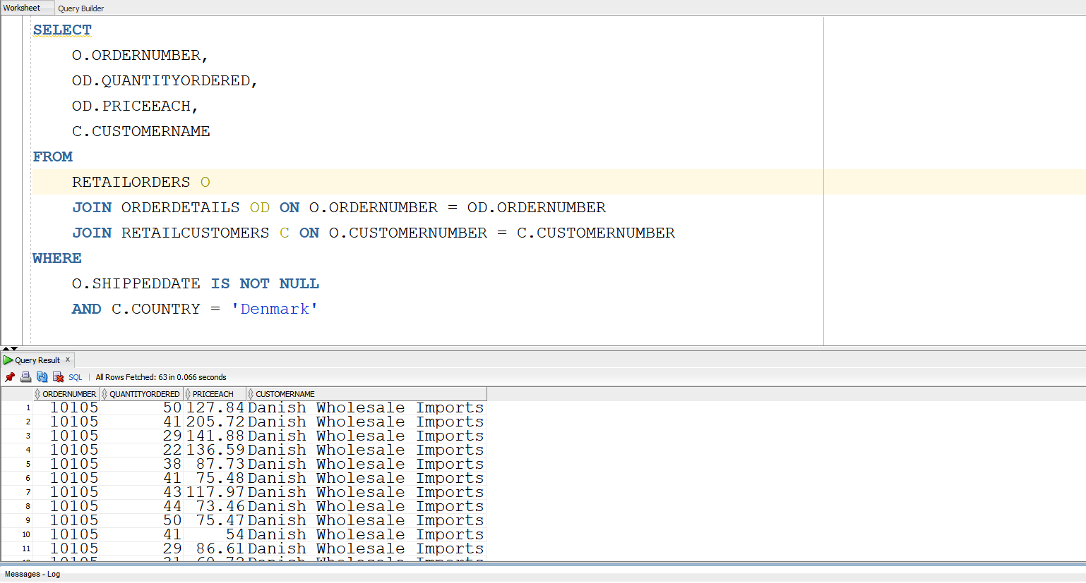

Q5
CREATE VIEW vwProductOrder AS
SELECT P.PRODUCTCODE, P.PRODUCTNAME, P.MSRP, P.BUYPRICE, OD.QUANTITYORDERED, (OD.PRICEEACH * OD.QUANTITYORDERED) AS TOTALPRICE
FROM RETAILPRODUCTS P
JOIN ORDERDETAILS OD ON P.PRODUCTCODE = OD.PRODUCTCODE;
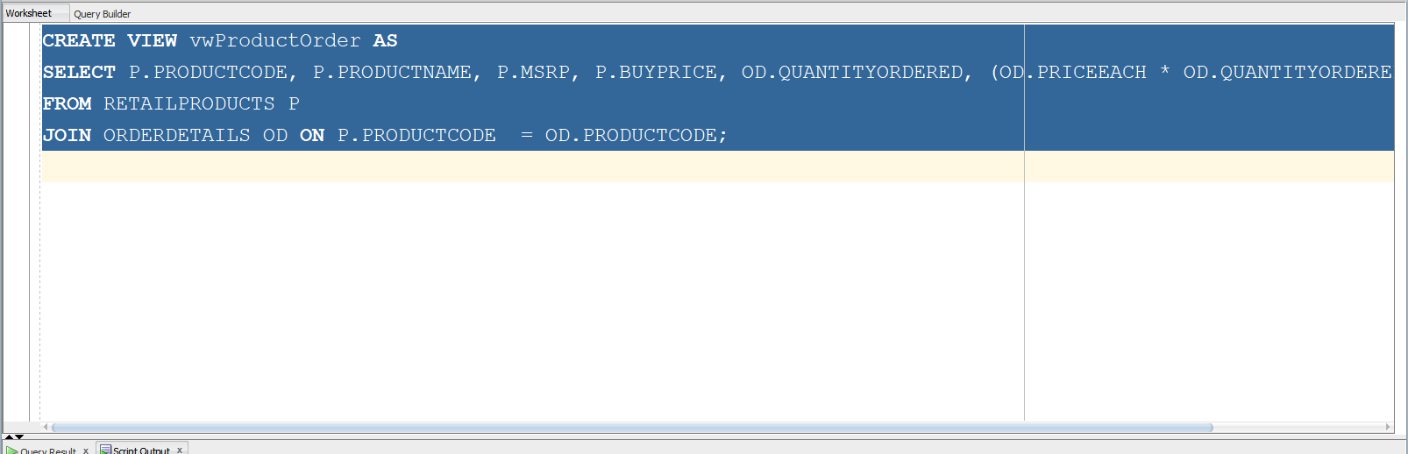
SELECT * FROM vwProductOrder;
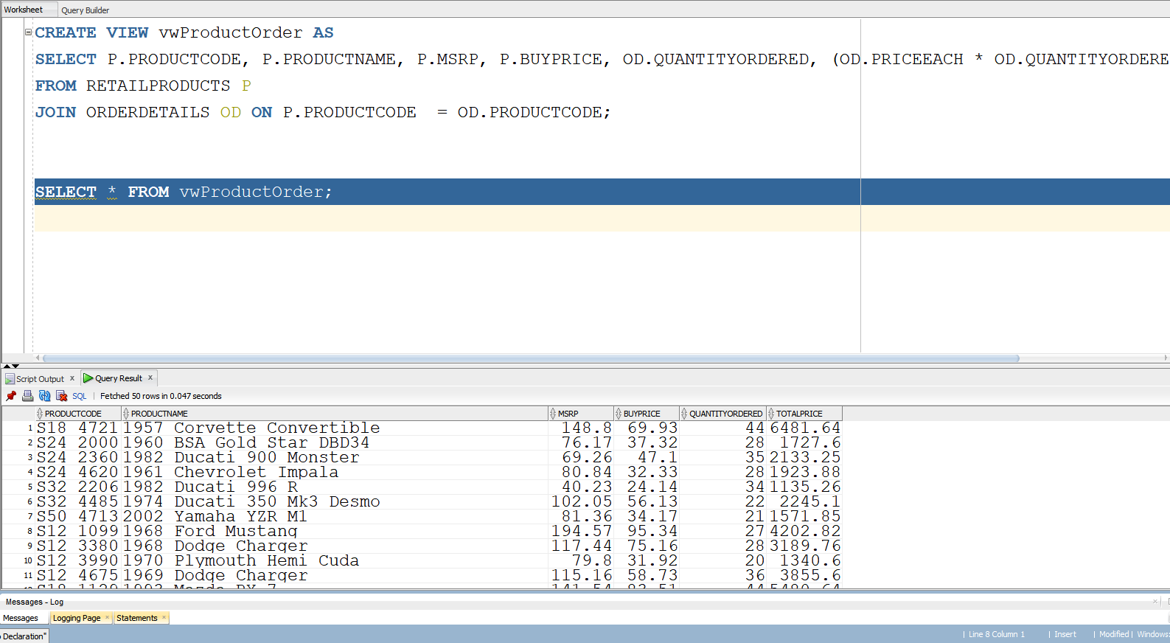

Q6
SELECT P.PRODUCTNAME, P.BUYPRICE, OD.ORDERLINENUMBER
FROM vwProductOrder PO
JOIN RETAILPRODUCTS P ON PO.PRODUCTCODE = P.PRODUCTCODE
JOIN ORDERDETAILS OD ON OD.PRODUCTCODE = P.PRODUCTCODE
WHERE P.BUYPRICE >= 30 AND P.BUYPRICE <= 40
AND lower(P.PRODUCTCODE) LIKE 's32%'
ORDER BY P.PRODUCTNAME, P.BUYPRICE;
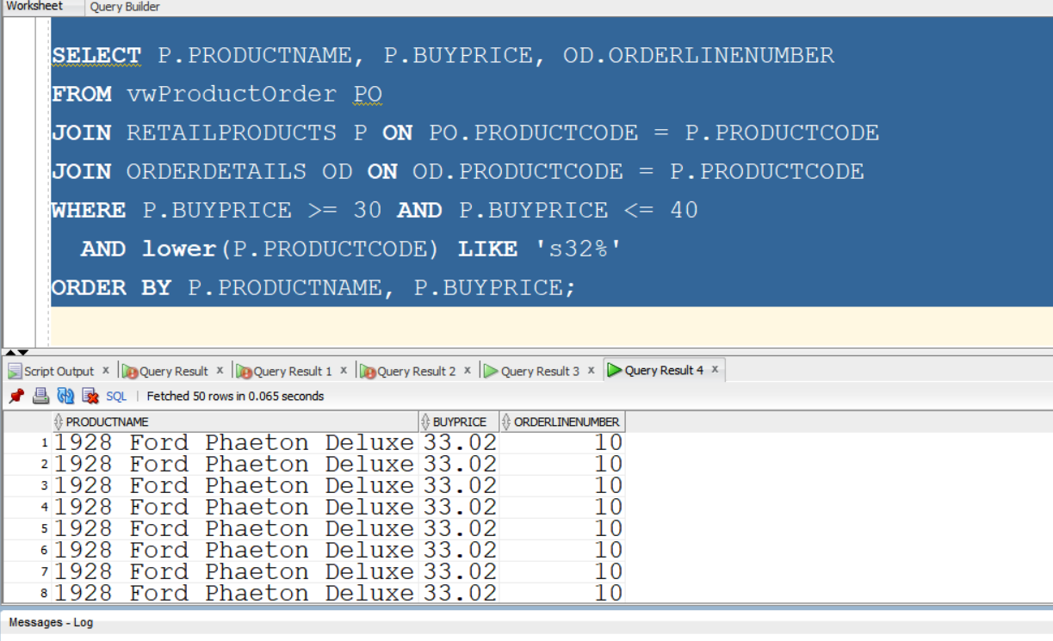

Q7
SELECT
C.CUSTOMERNUMBER,
C.CONTACTFIRSTNAME AS FIRSTNAME,
C.CONTACTLASTNAME AS LASTNAME,
C.PHONE,
C.CREDITLIMIT
FROM
RETAILCUSTOMERS C
LEFT OUTER JOIN
RETAILORDERS O ON C.CUSTOMERNUMBER = O.CUSTOMERNUMBER
WHERE
O.ORDERNUMBER IS NULL;
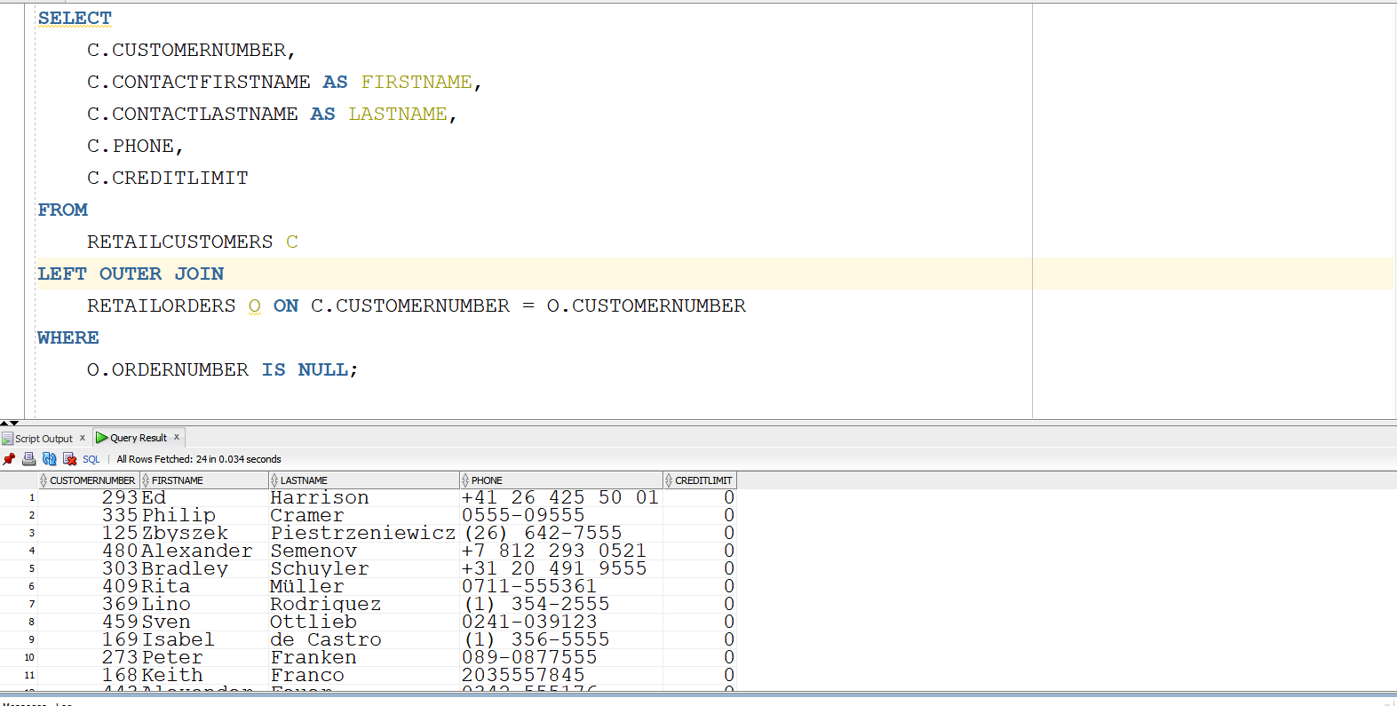

Q8
CREATE VIEW vwEmployeeManager AS
SELECT E1.FirstName AS EmployeeFirstName, E1.LastName AS EmployeeLastName,
E2.FirstName AS ManagerFirstName, E2.LastName AS ManagerLastName
FROM RETAILEMPLOYEES E1
LEFT JOIN RETAILEMPLOYEES E2 ON E1.Reportsto = E2.EmployeeNumber;
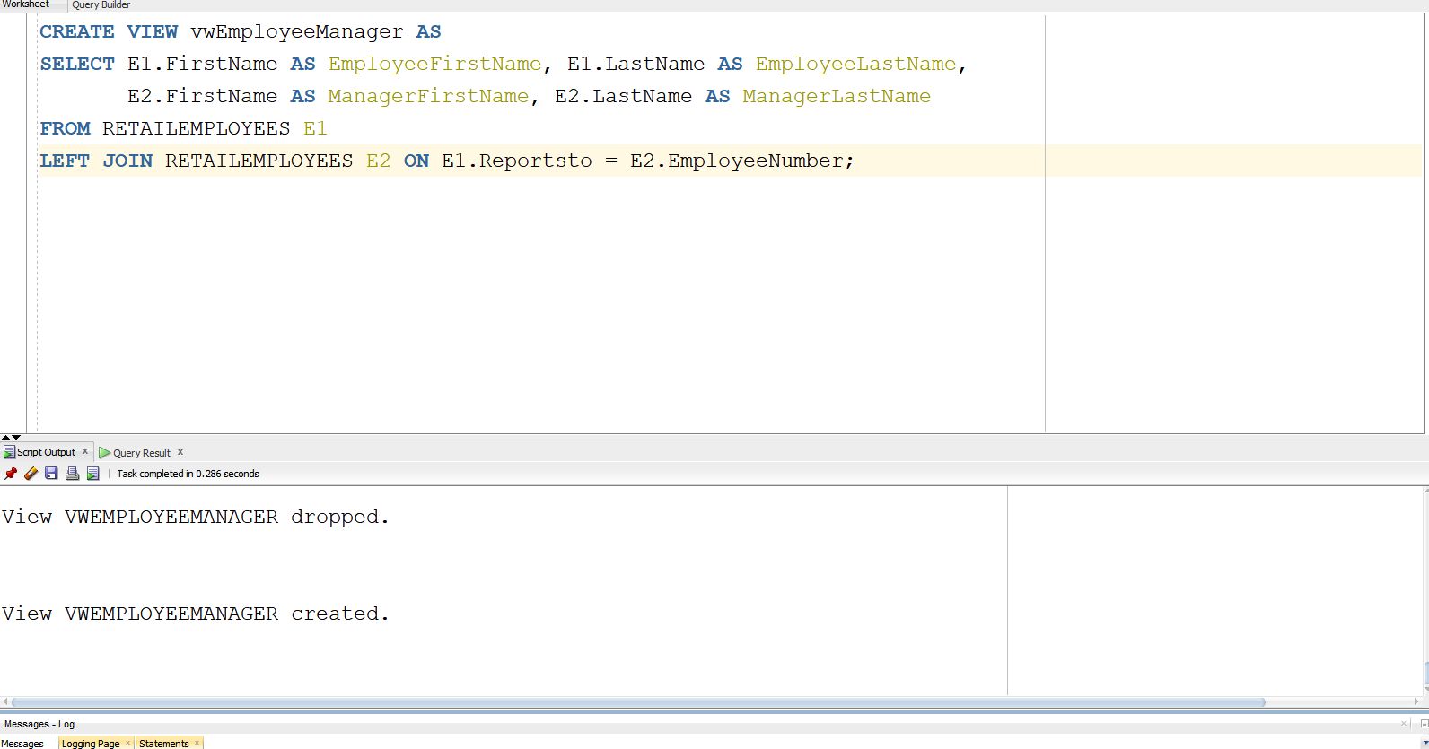
SELECT * FROM vwEmployeeManager;
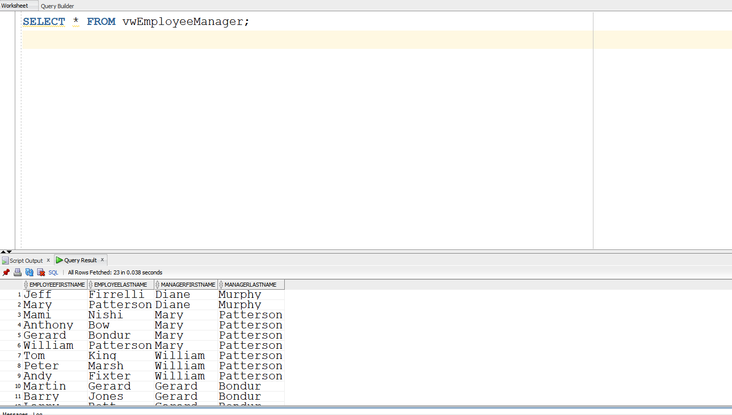

Q9
REPLACE VIEW vwEmployeeManager AS
SELECT
E1.FirstName AS EmployeeFirstName,
E1.LastName AS EmployeeLastName,
E2.FirstName AS ManagerFirstName,
E2.LastName AS ManagerLastName
FROM RETAILEMPLOYEES E1 JOIN RETAILEMPLOYEES E2 ON E1.Reportsto = E2.EmployeeNumber; 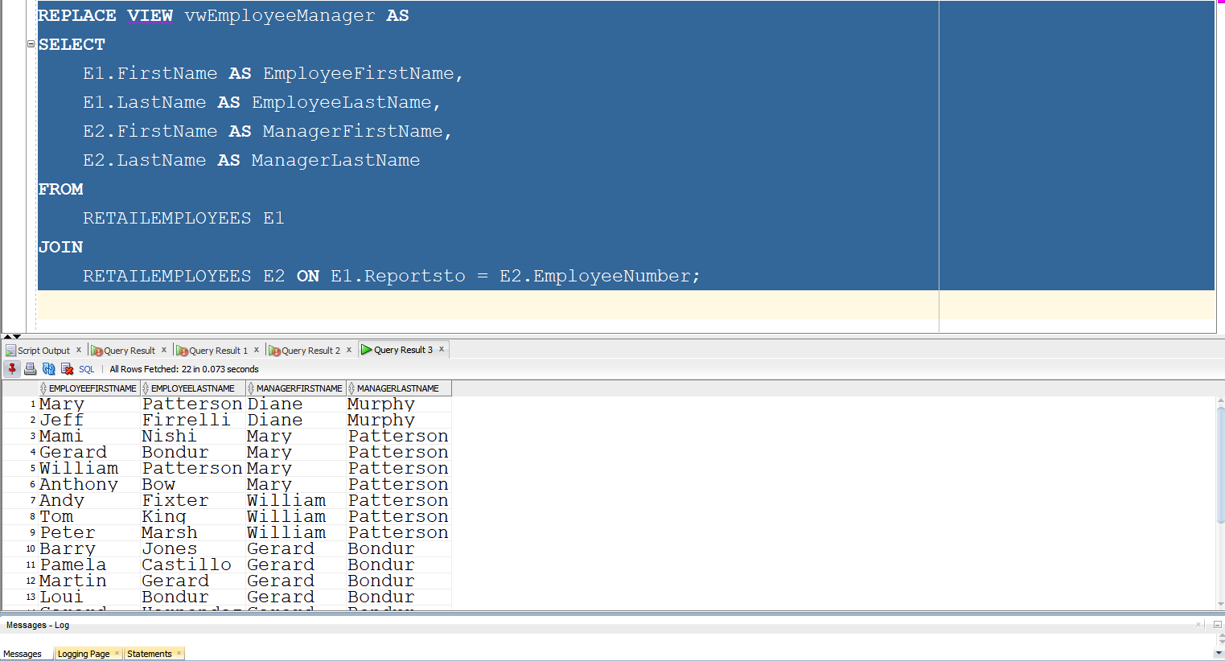

Q10
DROP VIEW vwProductOrder;
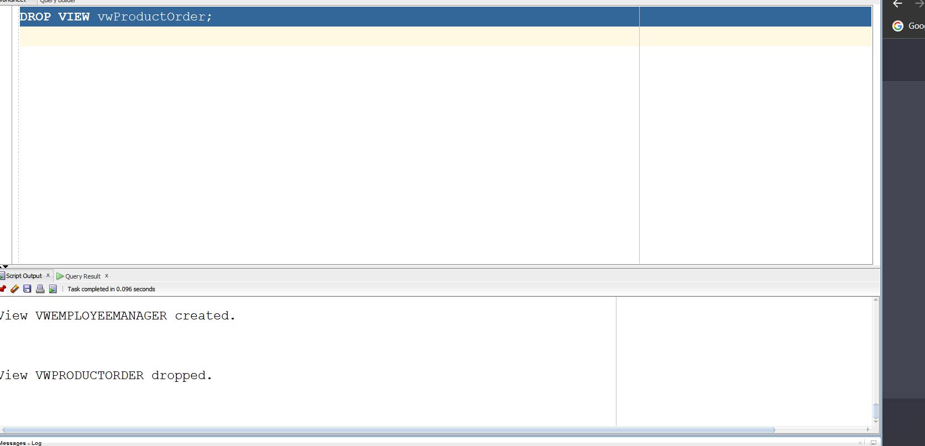
DROP VIEW vwEmployeeManager;
